**Author: Ilan Aizelman**

**Detect Lane Lines**

In this project, I used Python and OpenCV to find lane lines in the road images.

The following techniques are used:

* Color Selection
* Canny Edge Detection
* Region of Interest Selection
* Hough Transform Line Detection

Finally, I applied all the techniques to process video clips to find lane lines in them.

**Test Images**

The test images are shown below.

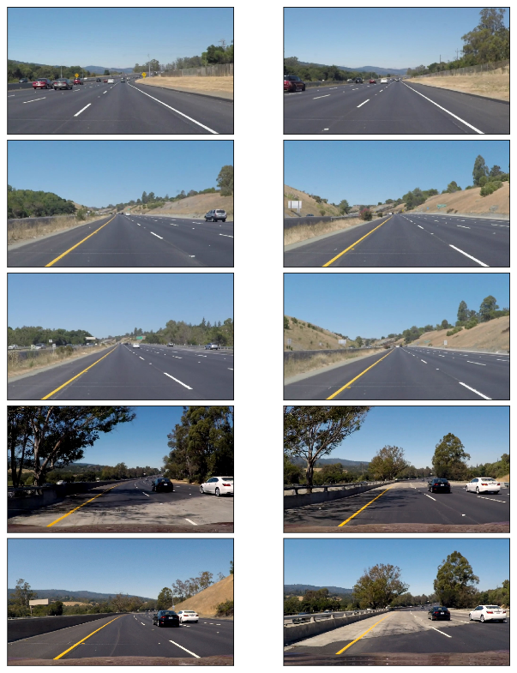

I use these images to test my pipeline (a series of image processing) to find lane lines on the road.

Lines are in white or yellow. A white lane is a series of alternating dots and short lines, which we need to detect as one line.

#### Color Selection

#### RGB Color Space

The images are loaded in RGB color space. Let’s try selecting only yellow and white colors in the images using the RGB channels (ref: [RGB Color Code Chart](http://www.rapidtables.com/web/color/RGB_Color.htm)).

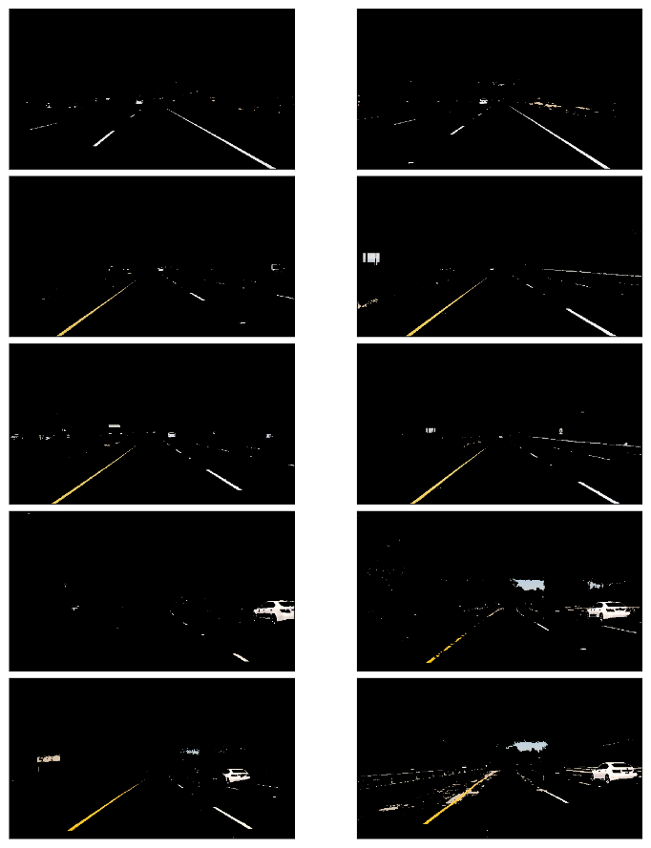

It looks pretty good except the two in which the yellow lines are not clear due to the dark shade from the tree on the left.

#### HSL and HSV Color Space

Using cv2.cvtColor, we can convert RGB image into different color space. For example, [HSL and HSV color space](https://en.wikipedia.org/wiki/HSL_and_HSV).

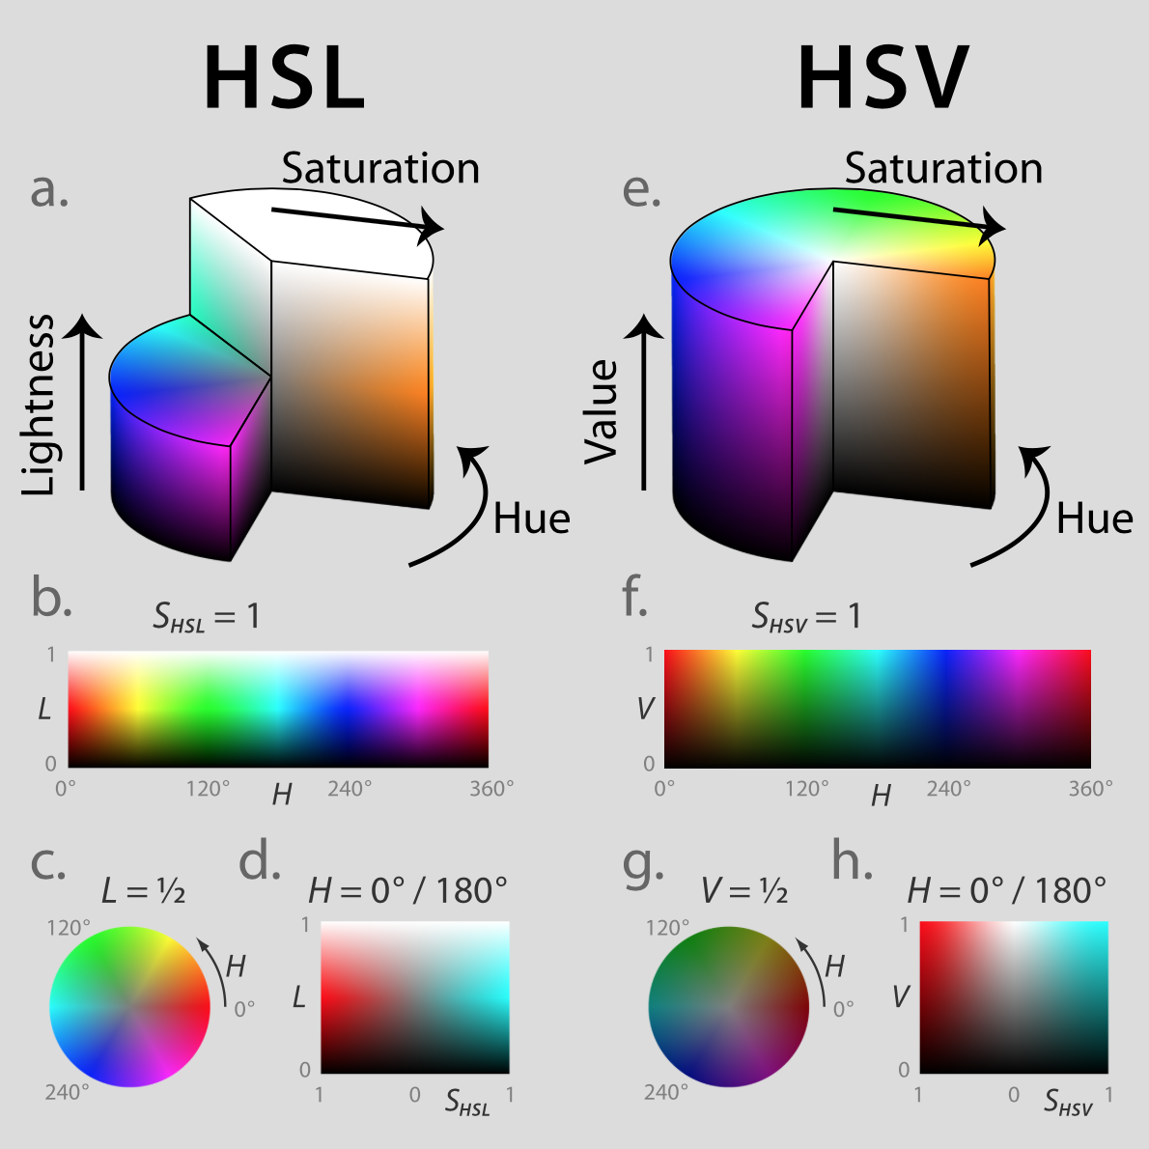

Image Source: <https://commons.wikimedia.org/wiki/File:Hsl-hsv_models.svg>

#### HSV Color Space

How does it look when RGB images are converted into HSV color space?

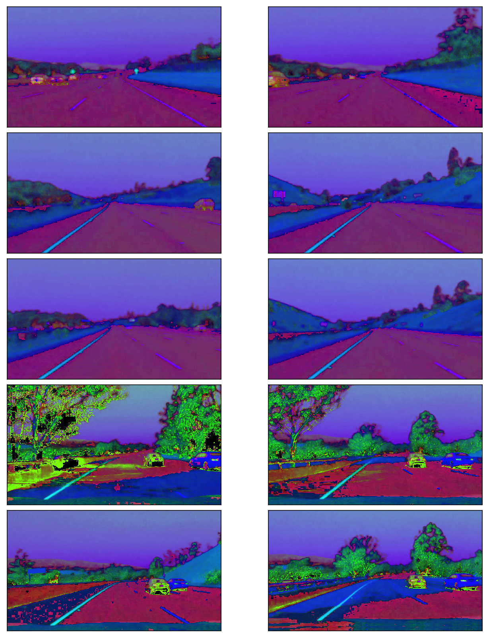

The yellow lines are very clear including the ones under the shades but the white lines are less clear.

#### HSL Color Space

How does it look like when images are converted from RGB to HSL color space?

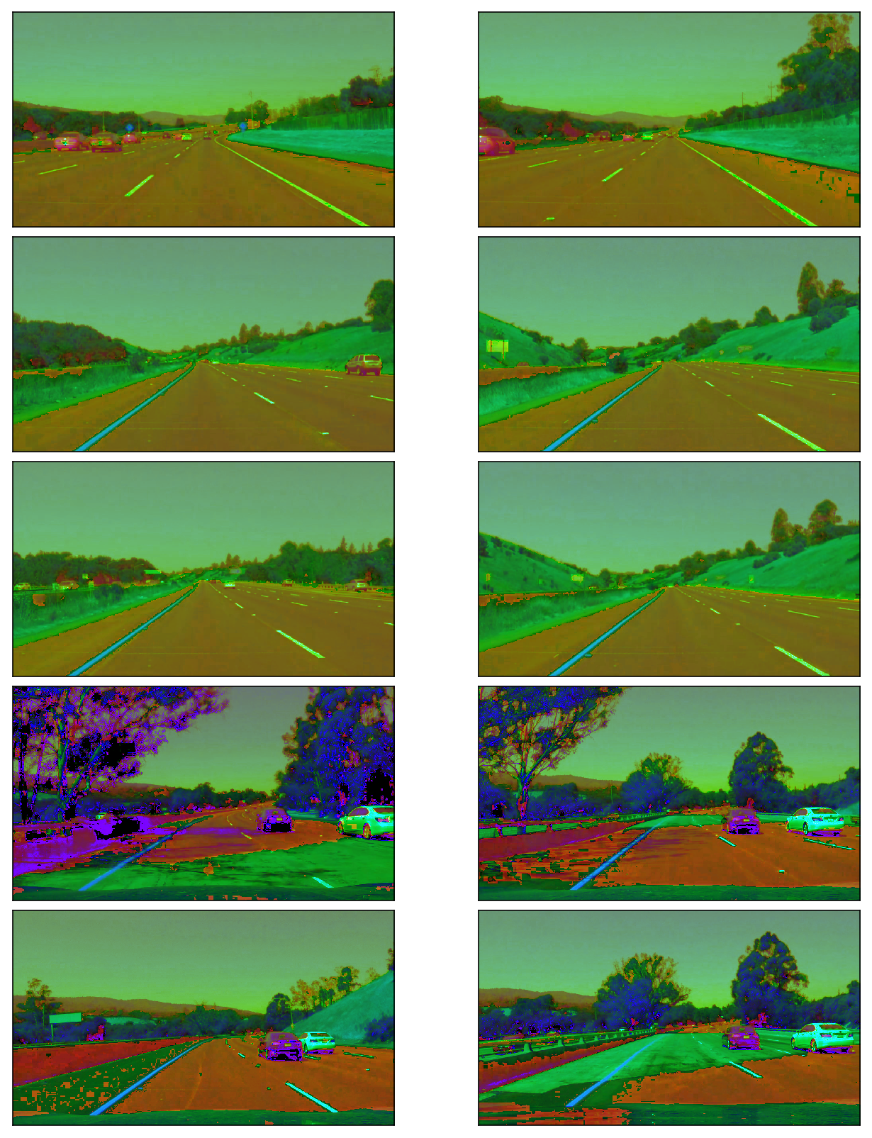

Both the white and yellow lines are clearly recognizable. Also, the yellow lines under the shades are clearly shown.

Let’s build a filter to select those white and yellow lines. I want to select particular range of each channels (Hue, Saturation and Light).

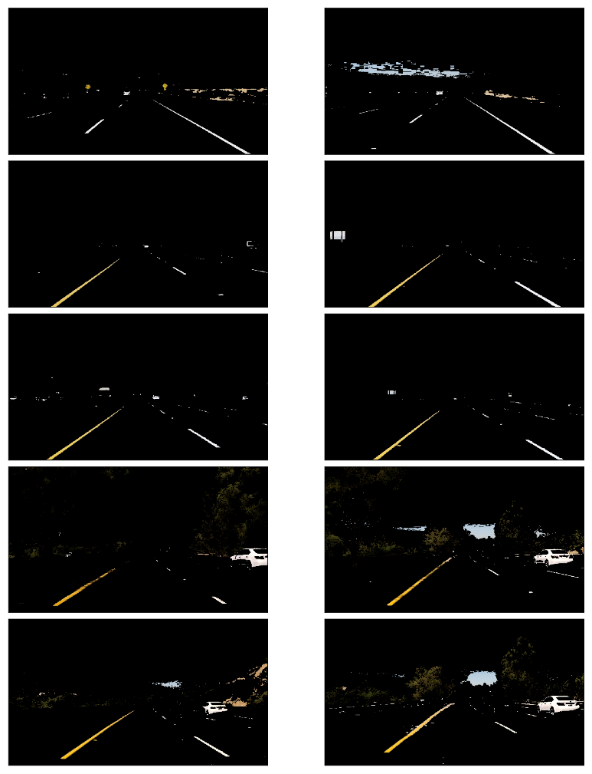

For the white color,

* I chose high **Light** value.
* I did not filter **Hue**, **Saturation** values.

For the yellow color,

* I chose **Hue** around 30 to choose yellow color.
* I chose relatively high **Saturation** to exclude yellow hills

The combined mask filters the yellow and white lines very clearly.

#### Canny Edge Detection

The Canny edge detector was developed by John F. Canny in 1986.

We want to detect edges in order to find straight lines especially lane lines. For this,

* Convert images into gray scale
* Smooth out rough lines
* Find edges

Let’s take a look at each step in details.

Note: [Canny Edge Detection Wikipedia](https://en.wikipedia.org/wiki/Canny_edge_detector) has a good description in good details.

#### Gray Scaling

The images should be converted into gray scaled ones in order to detect shapes (edges) in the images. This is because the Canny edge detection measures the magnitude of pixel intensity changes or gradients (more on this later).

Here, I’m converting the white and yellow line images from the above into gray scale for edge detection.

#### Gaussian Smoothing (Gaussian Blur)

When there is an edge (i.e. a line), the pixel intensity changes rapidly (i.e. from 0 to 255) which we want to detect. But before doing so, we should make the edges smoother. As you can see, the above images have many rough edges which causes many noisy edges to be detected.

I applied [Gaussian Blur](https://en.wikipedia.org/wiki/Gaussian_blur) to make the edges smoother.

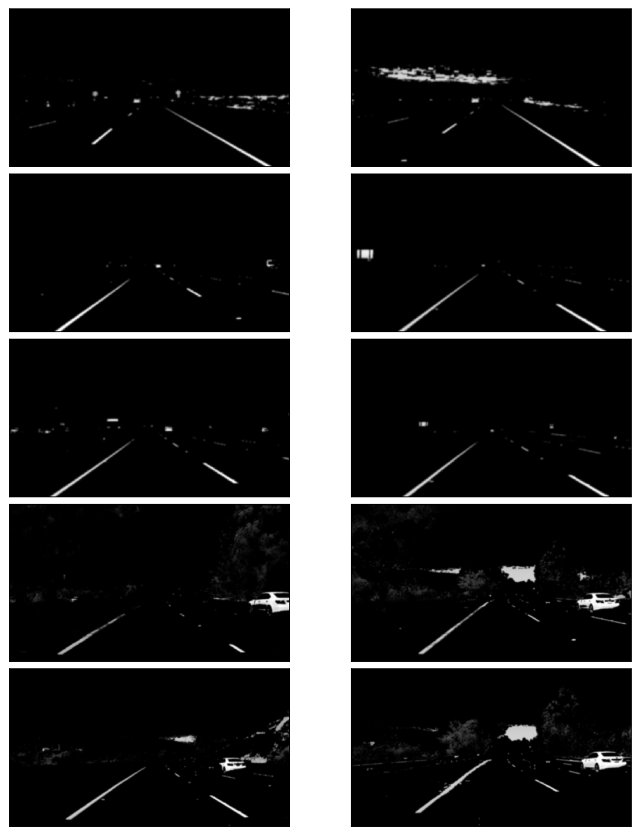

#### Edge Detection

I’m using a technique called Canny edge detection which make use of the fact that edges has high gradients (how sharply image changes — for example, dark to white).

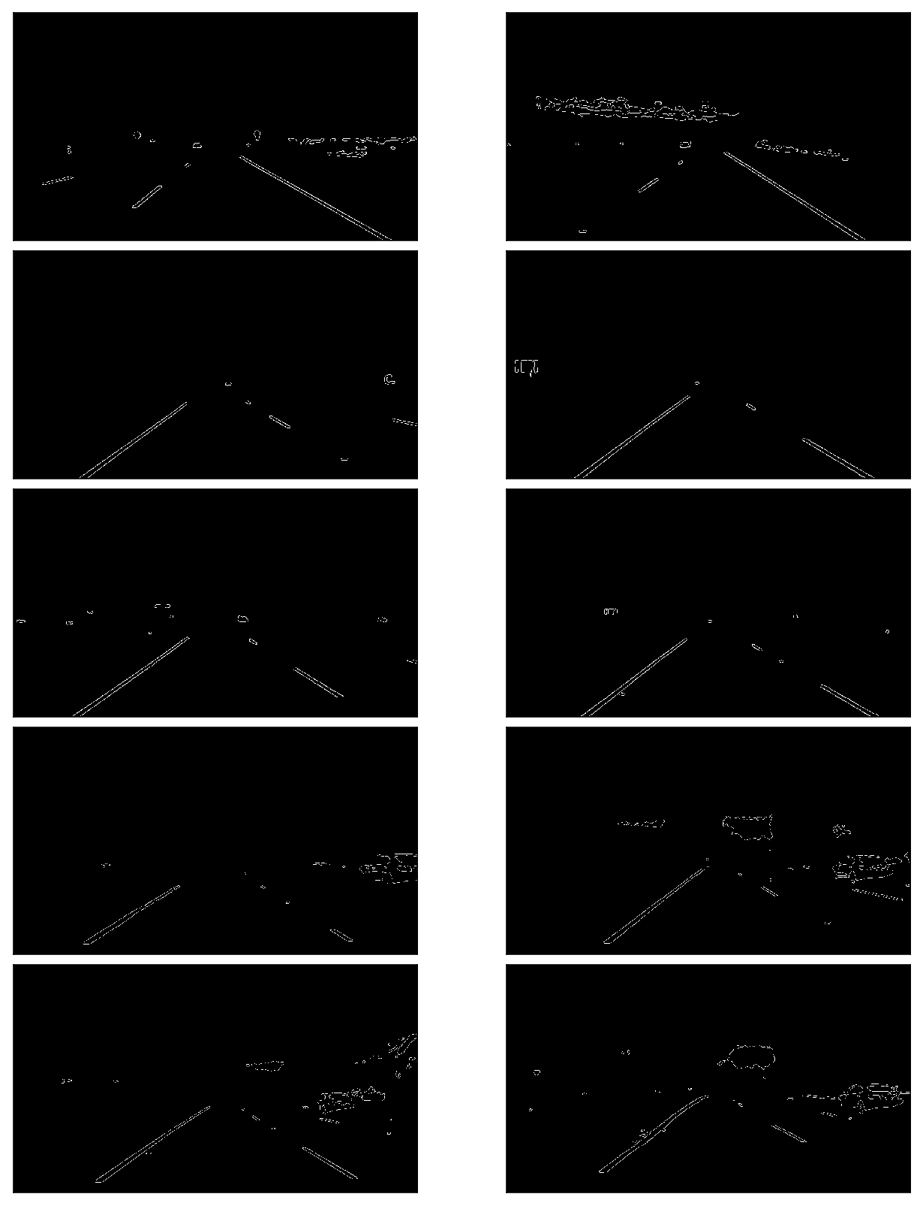

#### Region of Interest Selection

When finding lane lines, we don’t need to check the sky and the hills.

Roughly speaking, we are interested in the area surrounded by the red lines below:

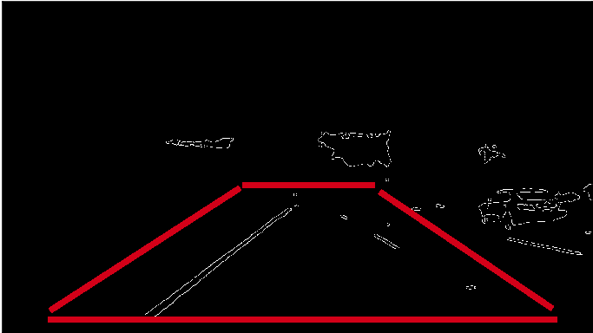

Excluding everything except for the region of interest:

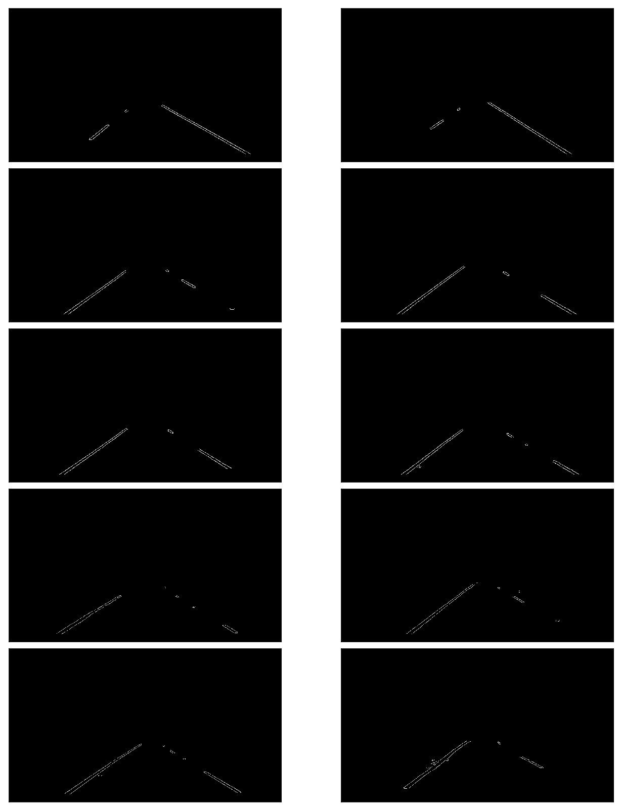

Now we have lane lines but we need to recognize them as lines. Especially, two lines: the left lane and the right lane.

#### Hough Transform Line Detection

I’m using [Hough Line Transform](https://en.wikipedia.org/wiki/Hough_transform) to detect lines in the edge images.

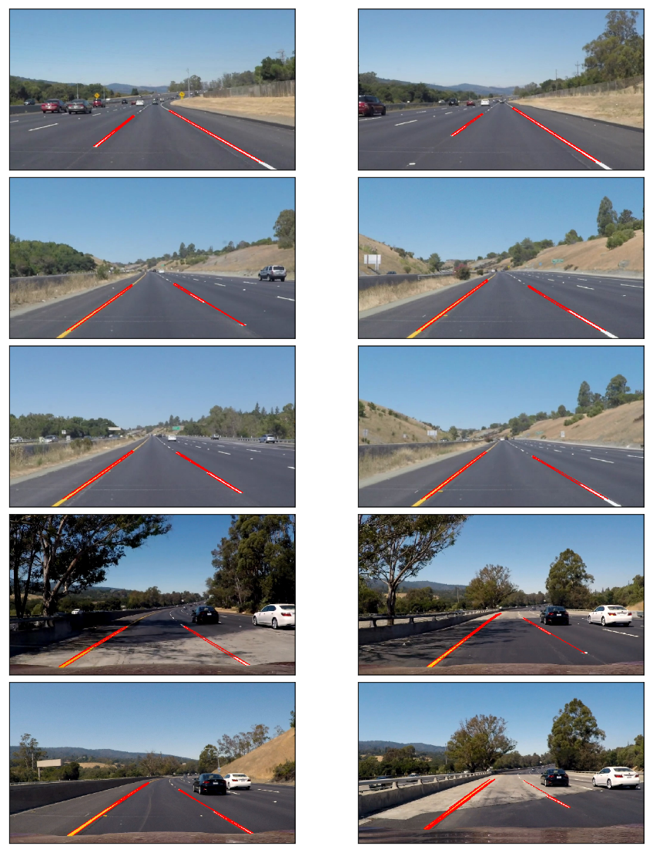

#### Averaging and Extrapolating Lines

There are multiple lines detected for a lane line. We should come up with an averaged line for that.

Also, some lane lines are only partially recognized. We should extrapolate the line to cover full lane line length.

We want two lane lines: one for the left and the other for the right. The left lane should have a positive slope, and the right lane should have a negative slope. Therefore, we’ll collect positive slope lines and negative slope lines separately and take averages.

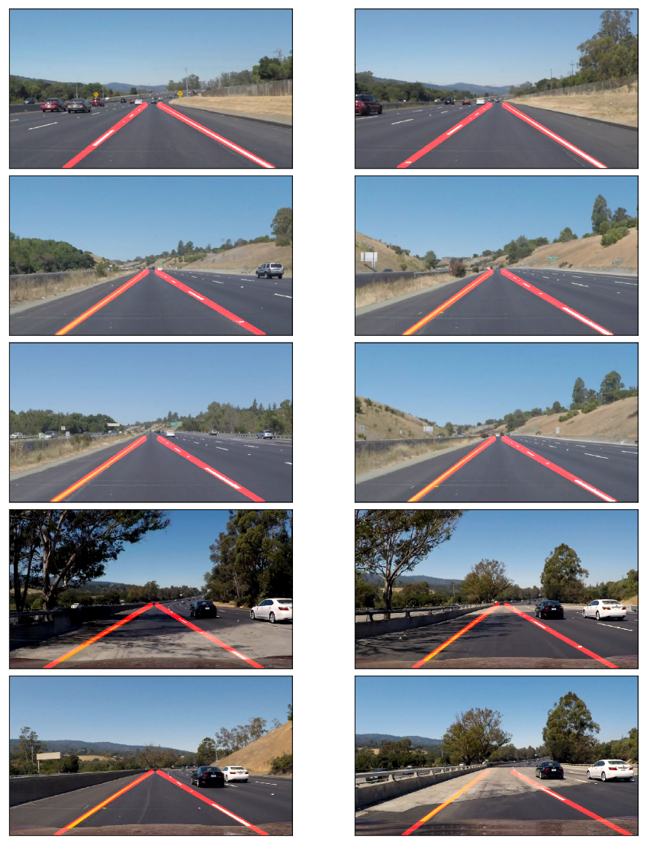

#### Video Clips

Finally, I’m drawing the lane lines on the video clips. When doing this, I’m calculating the average lane lines across multiple video image frames to make it smoother (i.e. not bumpy / jumping around).

#### Conclusion

The project was successful in that the video images clearly show the lane lines are detected properly and lines are very smoothly handled.

It only detects the straight lane lines. It is an advanced topic to handle curved lanes (or the curvature of lanes). We’ll need to use perspective transformation and also poly fitting lane lines rather than fitting to straight lines.

Having said that, the lanes near the car are mostly straight in the images. The curvature appears at further distance unless it’s a steep curve. So, this basic lane finding technique is still very useful.

Another thing is that it won’t work for steep (up or down) roads because the region of interest mask is assumed from the center of the image.

For steep roads, we first need to detect the horizontal line (between the sky and the earth) so that we can tell up to where the lines should extend.